HOME PAGE

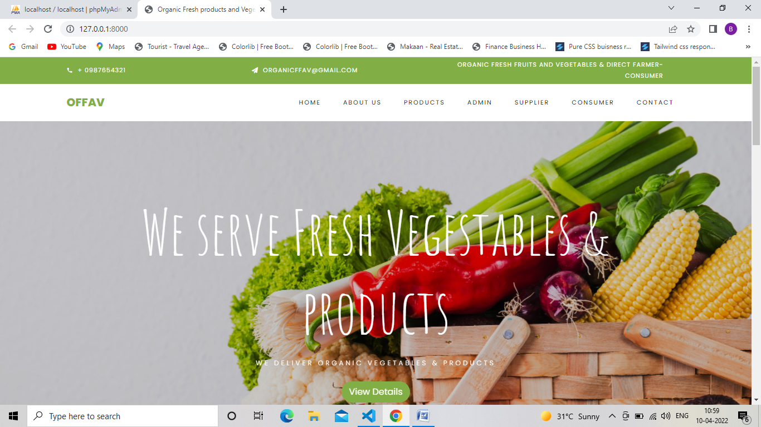

ABOUT US PAGE



PRODUCTS PAGE

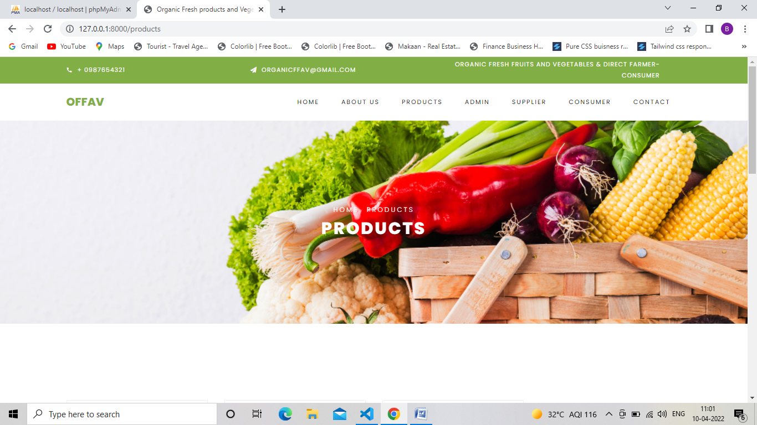

ADMIN LOGIN

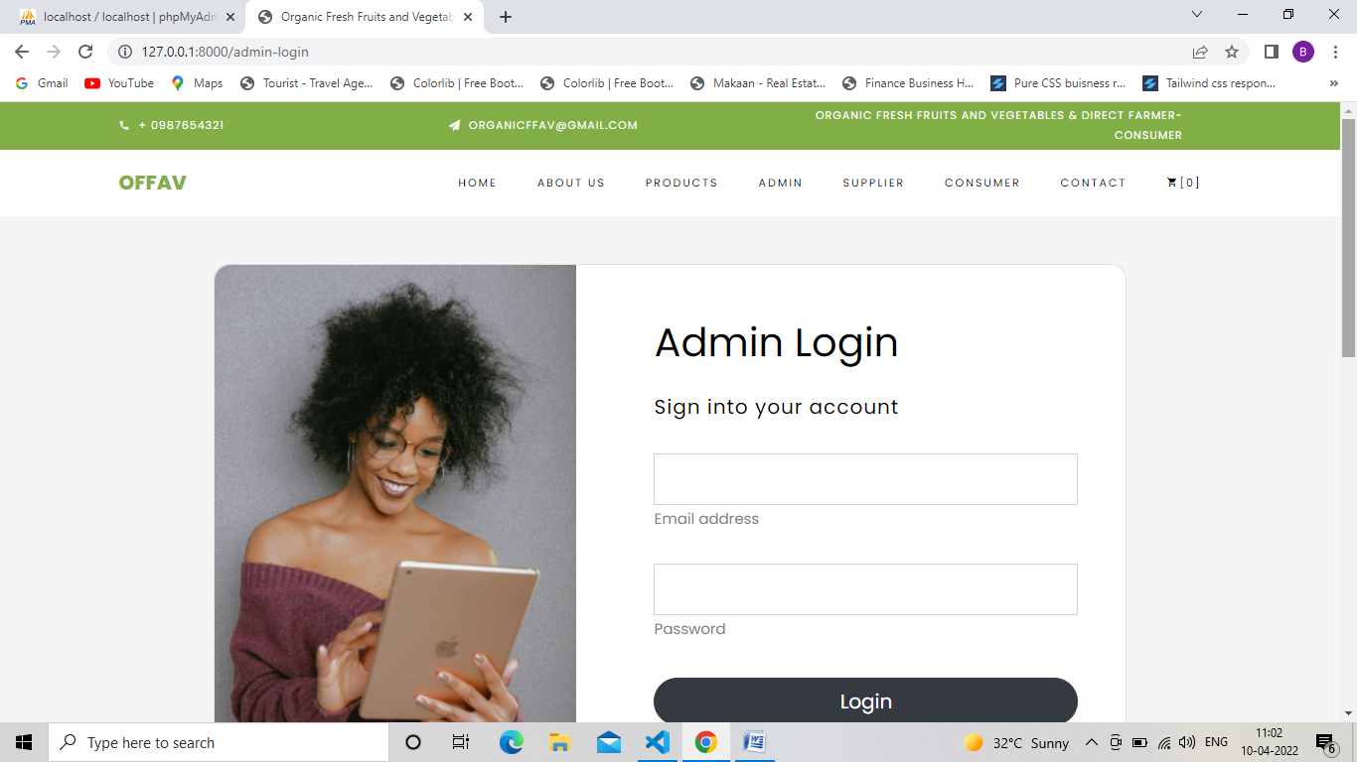

SUPPLIER LOGIN

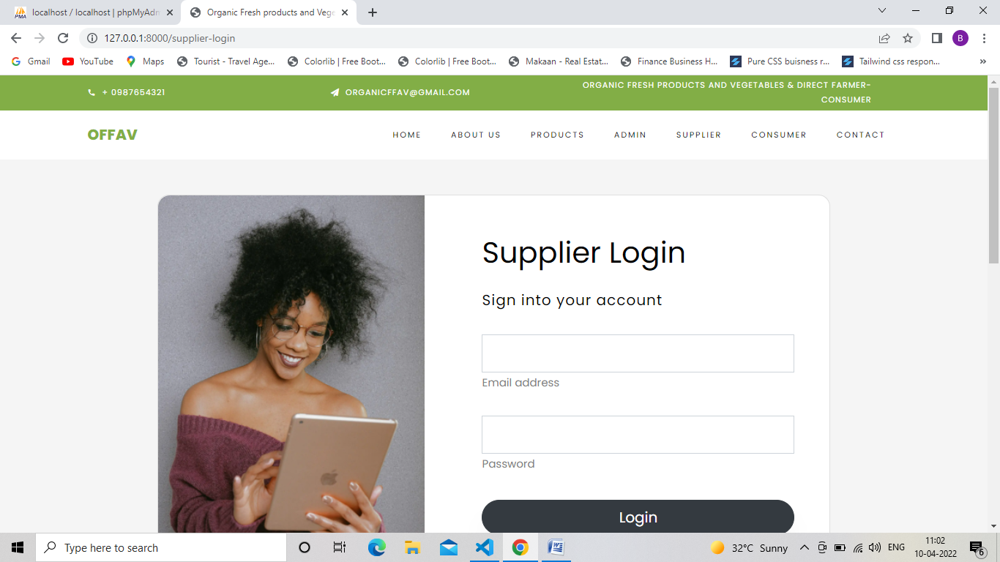

CONSUMER LOGIN

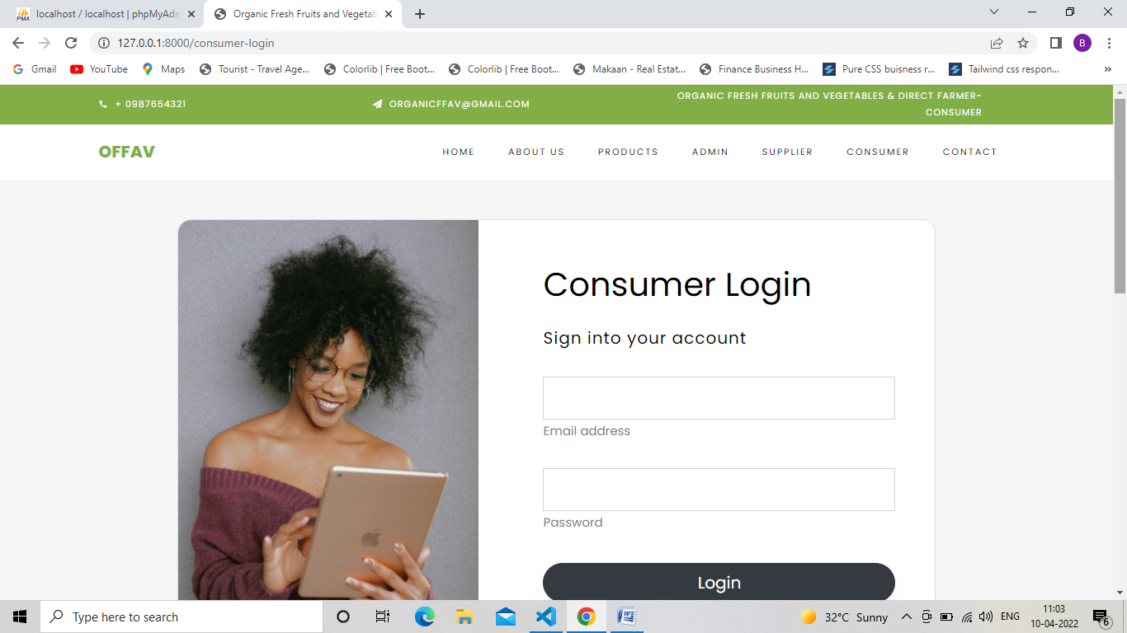

CONTACT

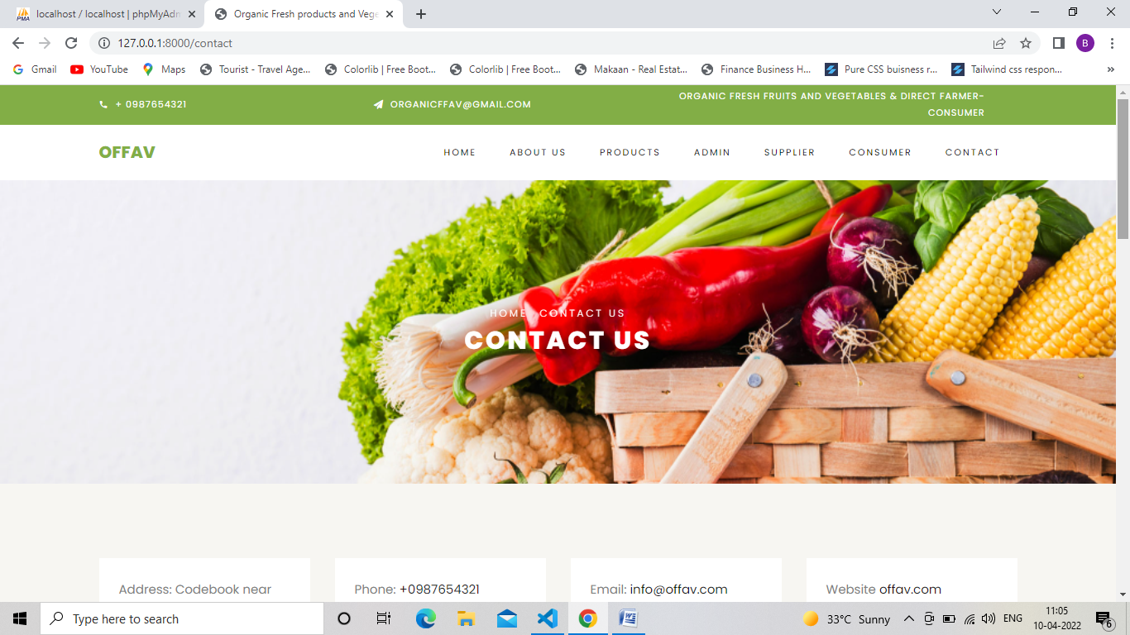

ADMIN/ADMIN-DASHBOARD

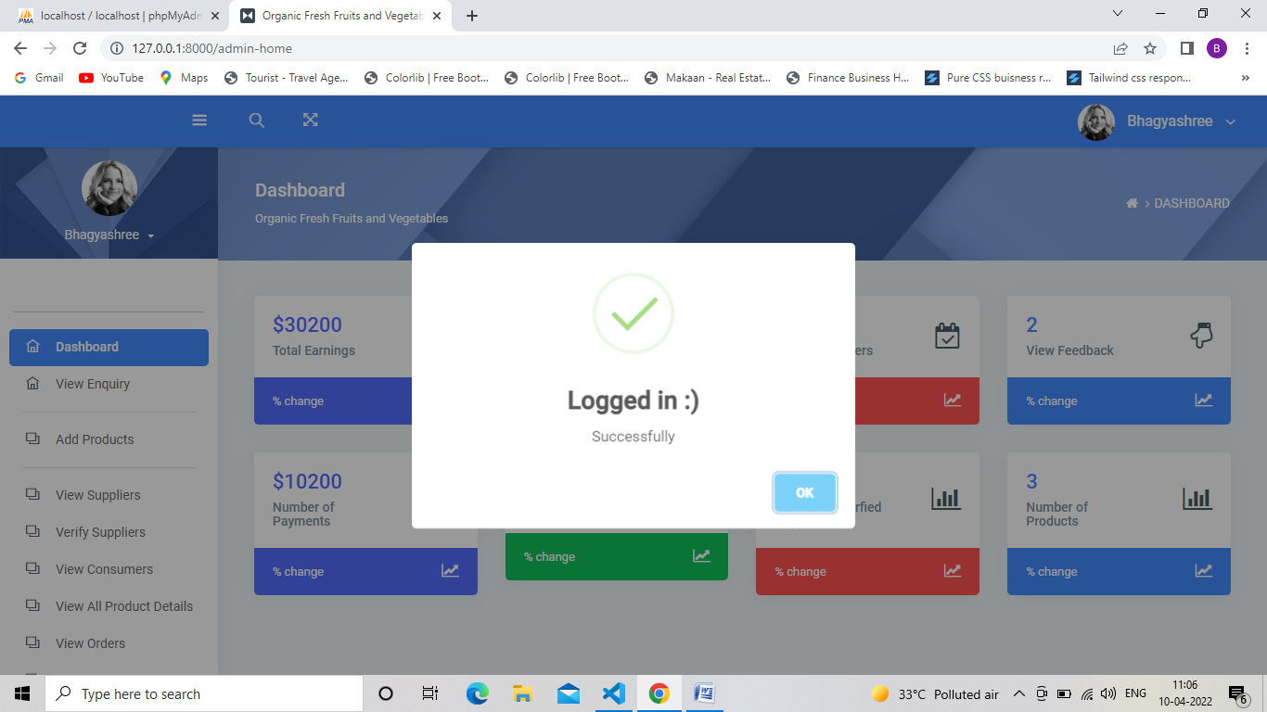

ADMIN/ADMIN-ADMIN DASHBOARD

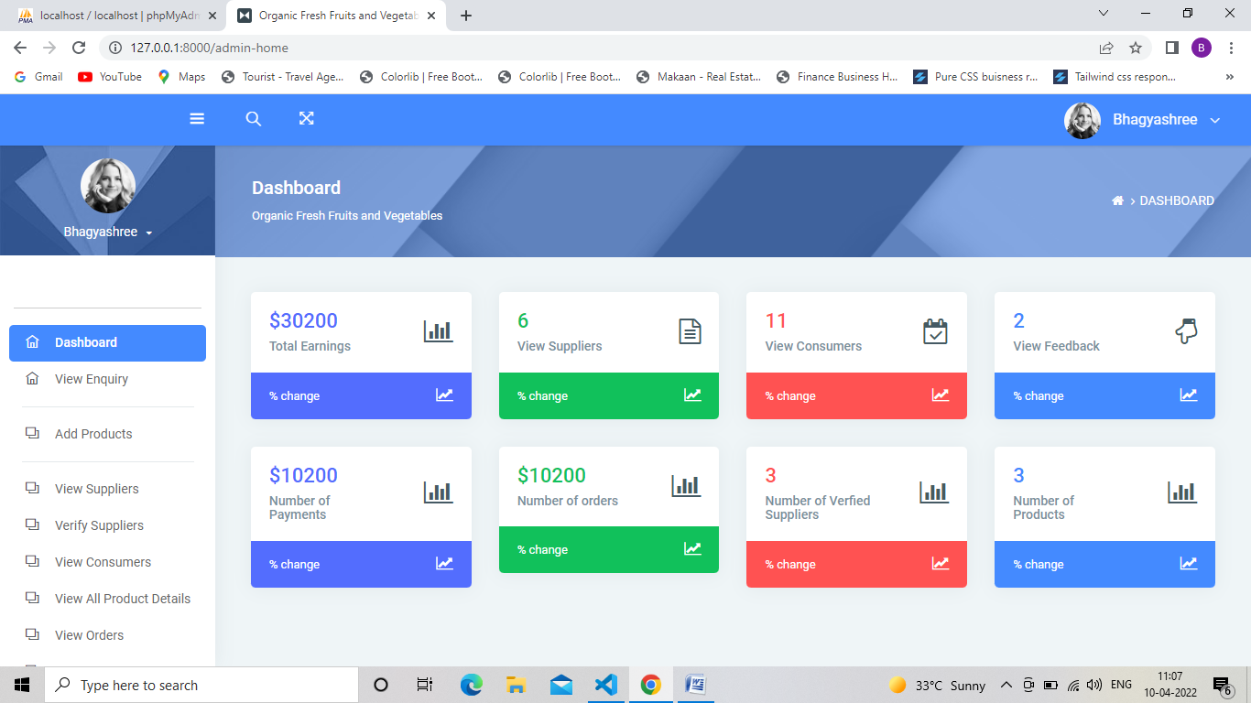

ADMIN/ADMIN-VIEW ENQUIRY

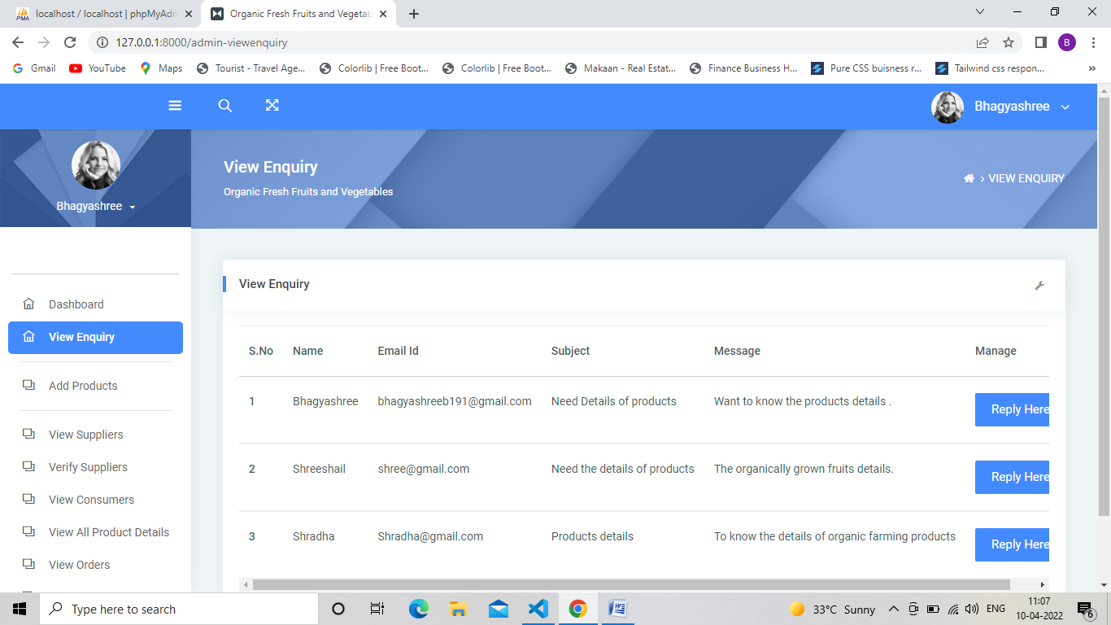

ADMIN/ADMIN-ADD PRODUCTS

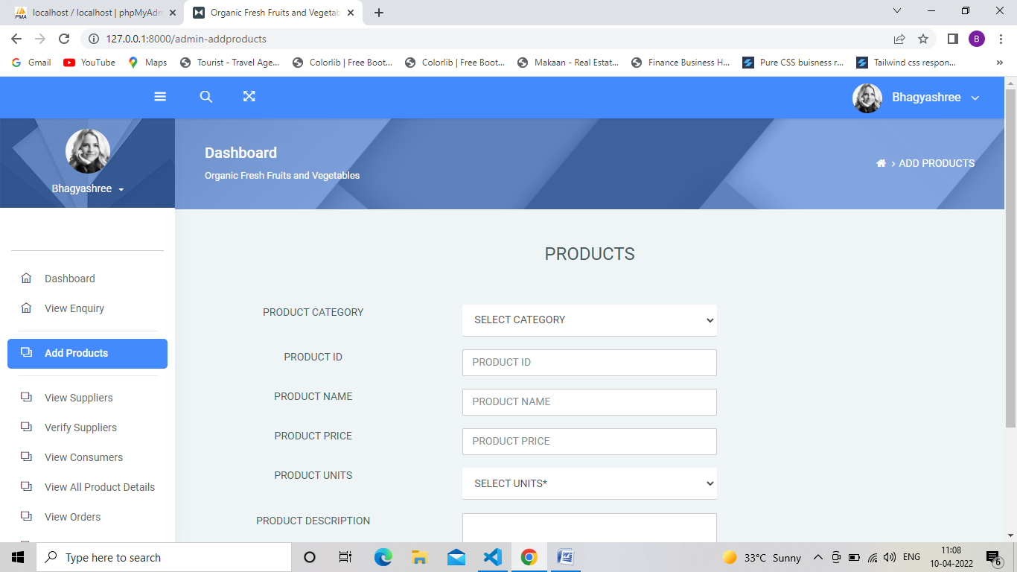

ADMIN/ADMIN-VIEW SUPPLIER

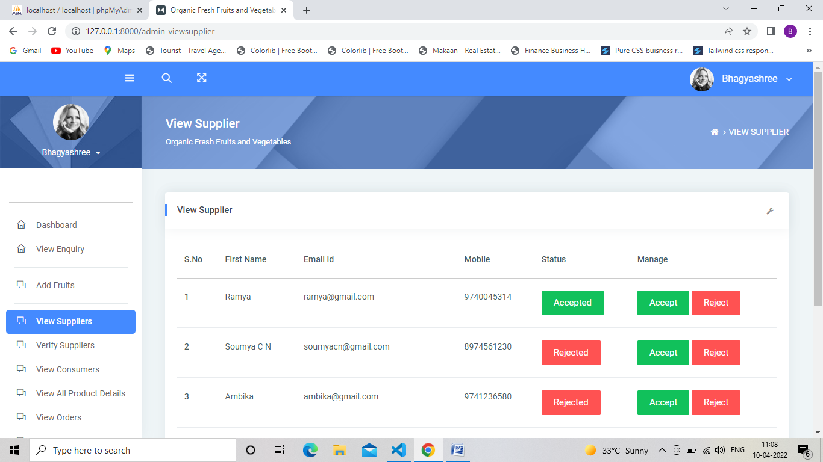

ADMIN/ADMIN-VERIFY SUPPLIER

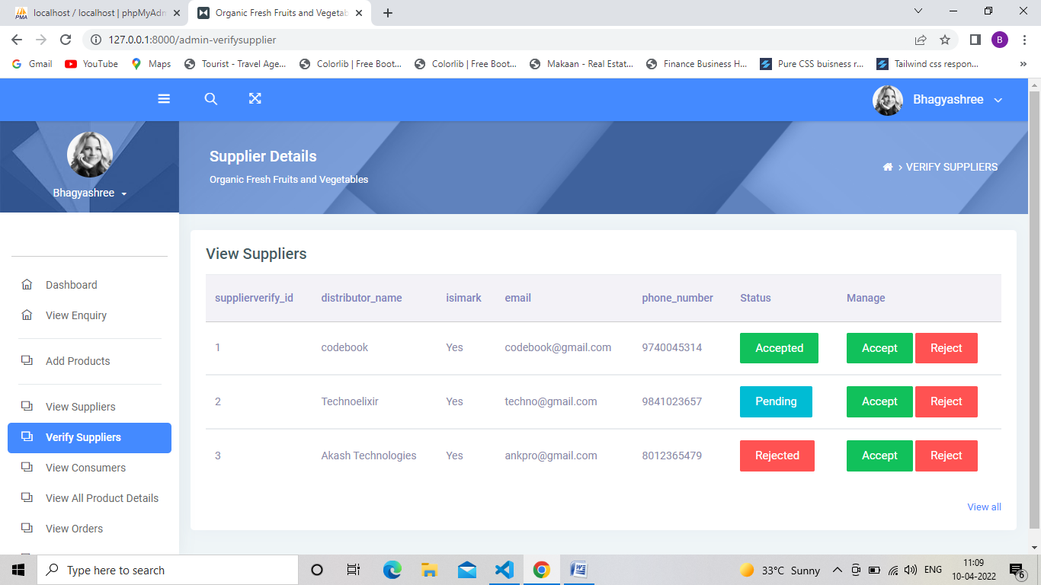

ADMIN/ADMIN-VIEW CONSUMERS

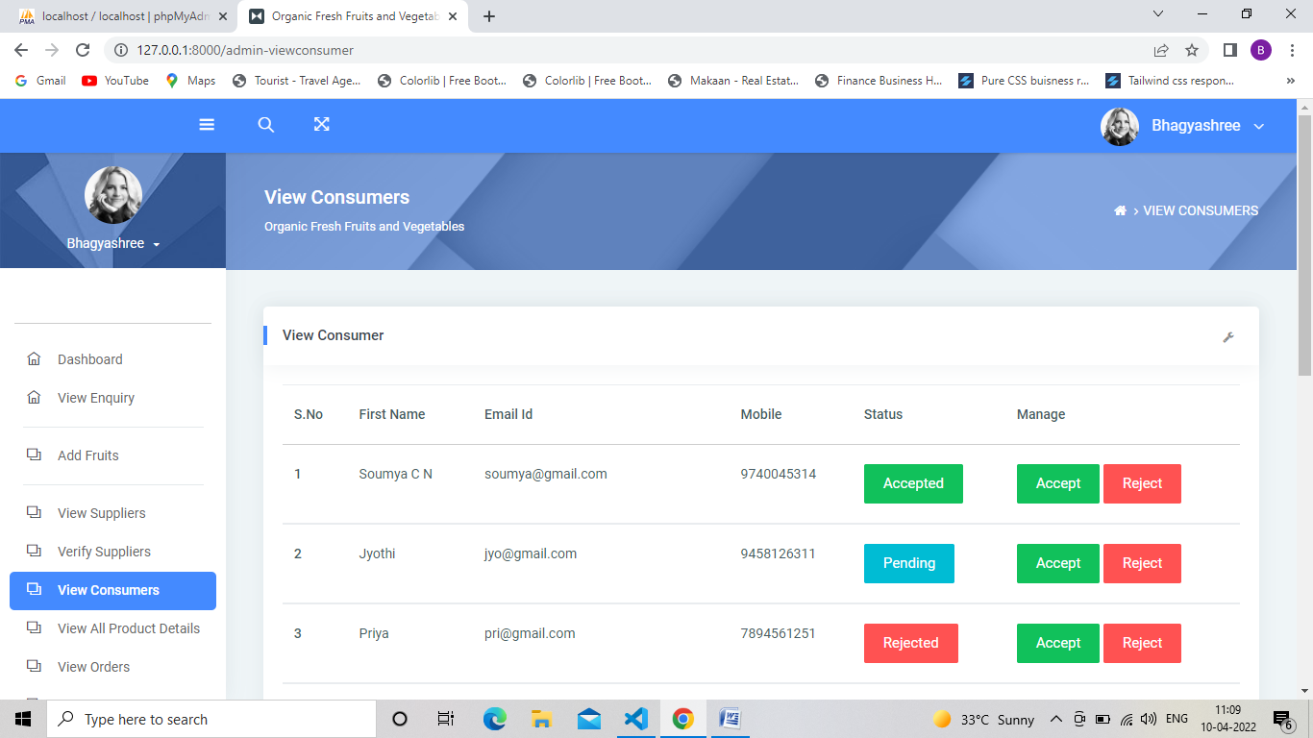

ADMIN/ADMIN-VIEW ALL ADDED PRODUCTS

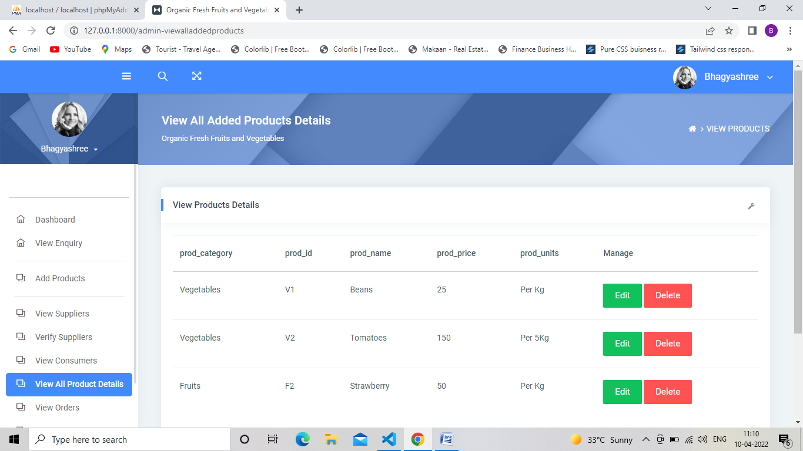

ADMIN/ADMIN-VIEW ORDERS

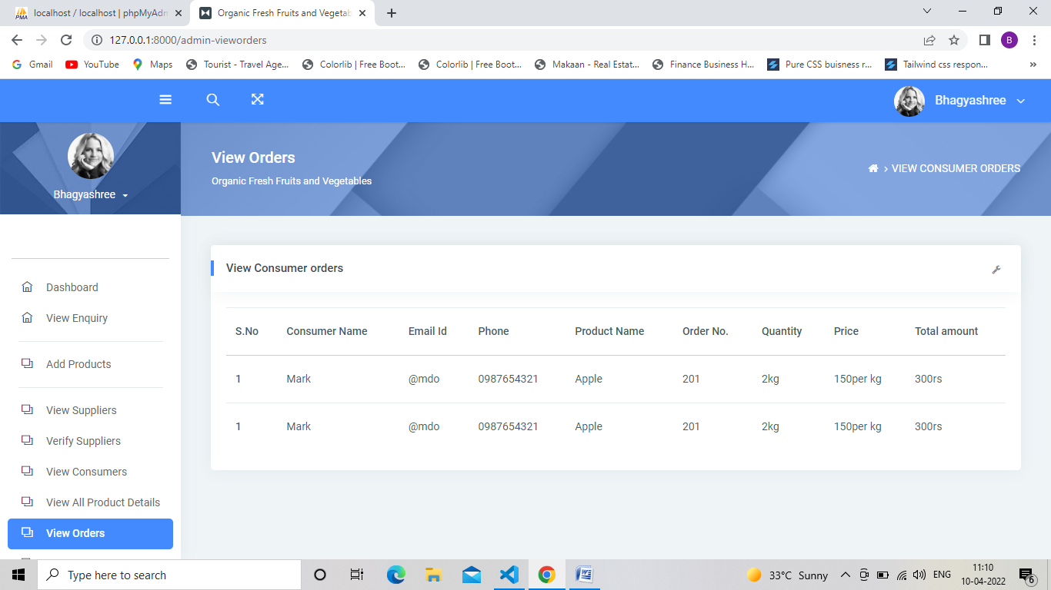

ADMIN/ADMIN-VIEW PAYMENTS

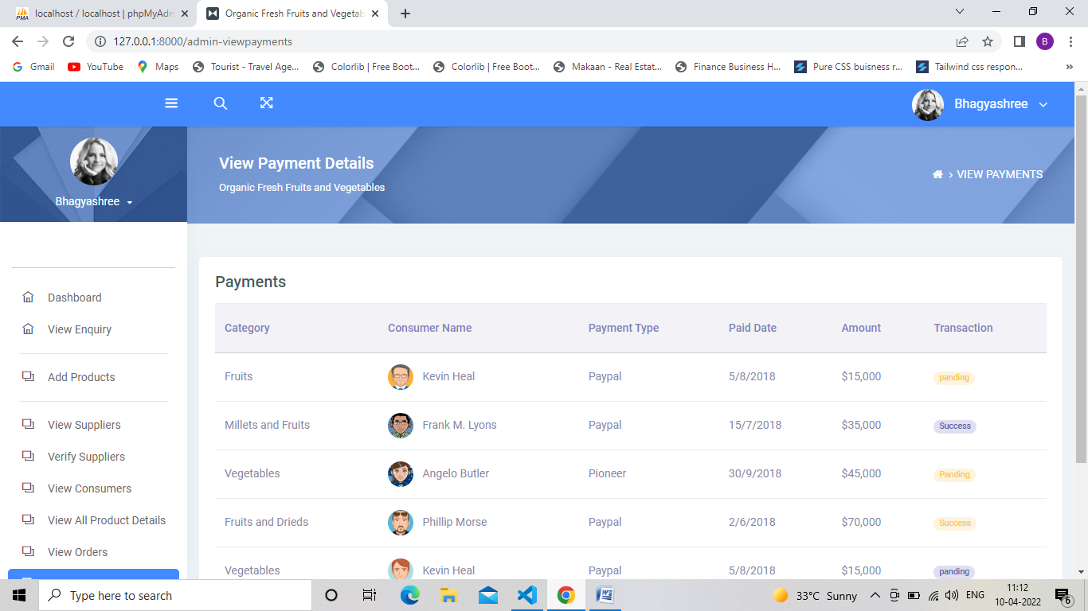

ADMIN/VIEW FEEDBACK

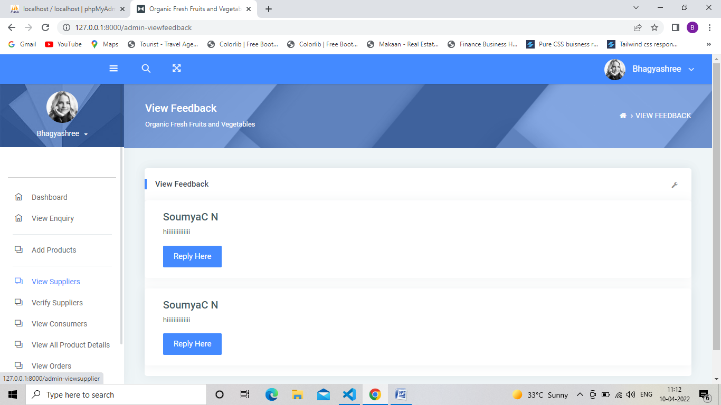

ADMIN/ADMIN LOGOUT

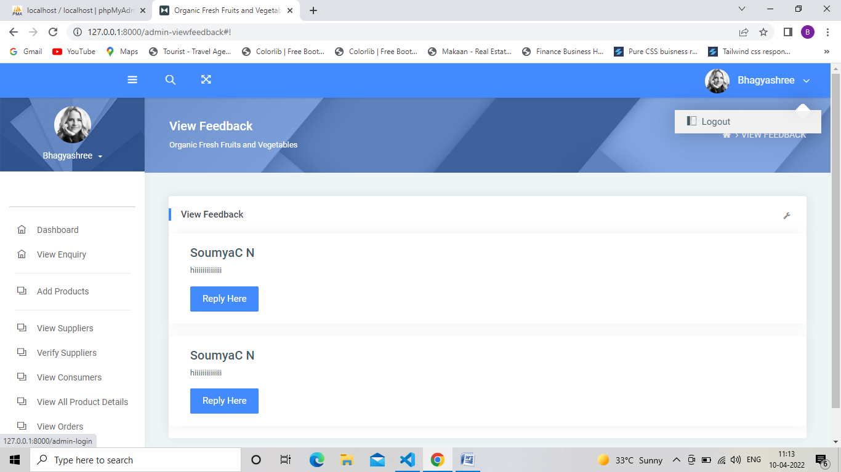

SUPPLIER-REGISTRATION

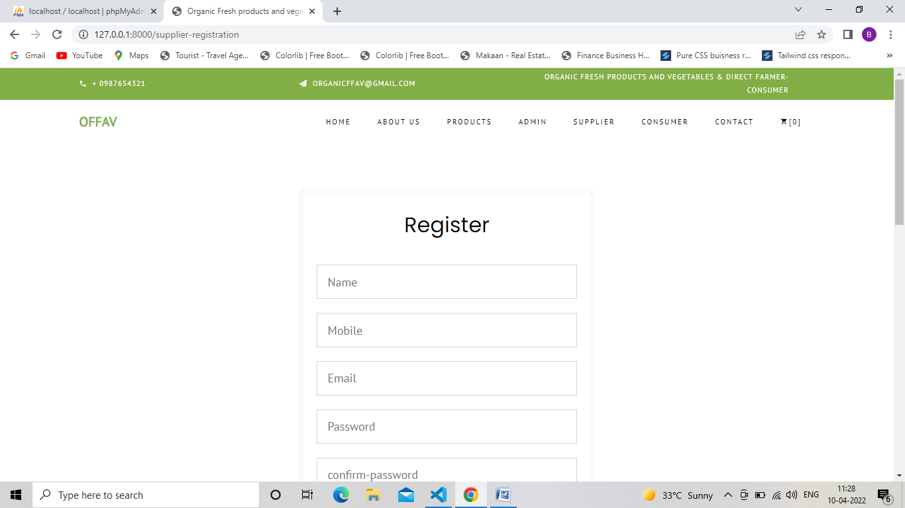

SUPPLIER/SUPPLIER-DASHBOARD

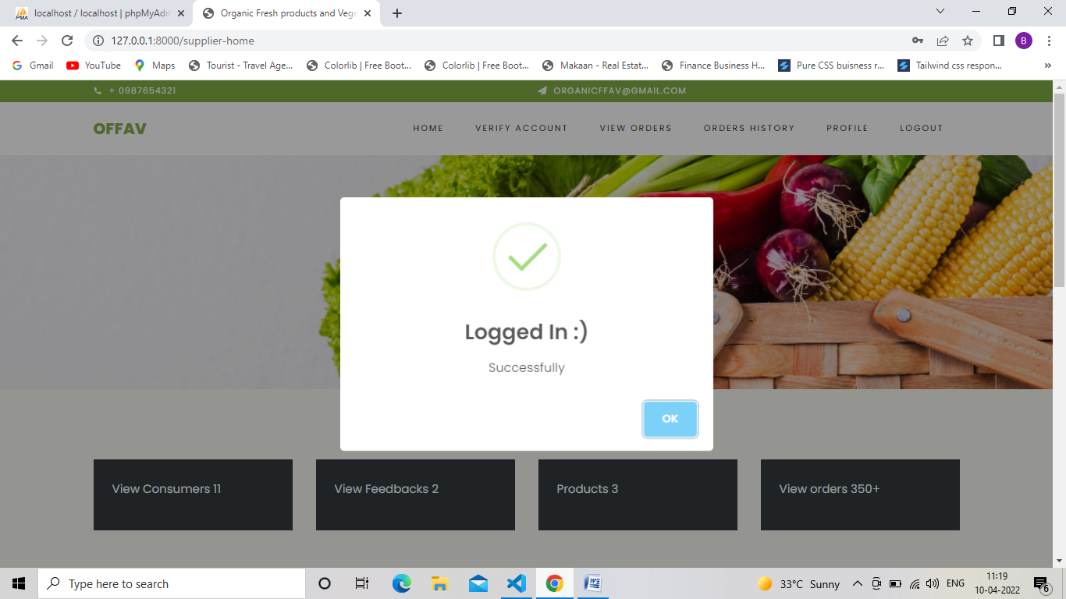

SUPPLIER/SUPPLIER-HOME

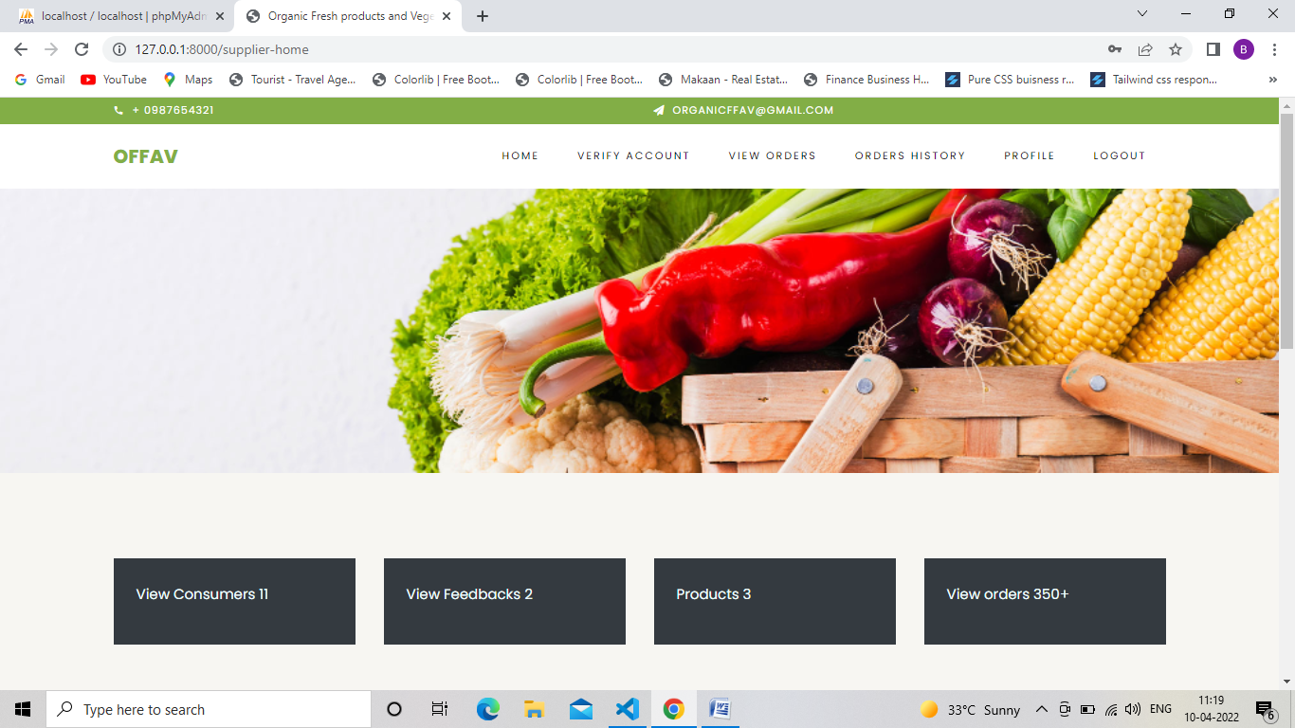

SUPPLIER/SUPPLIER-VERIFY ACCOUNT

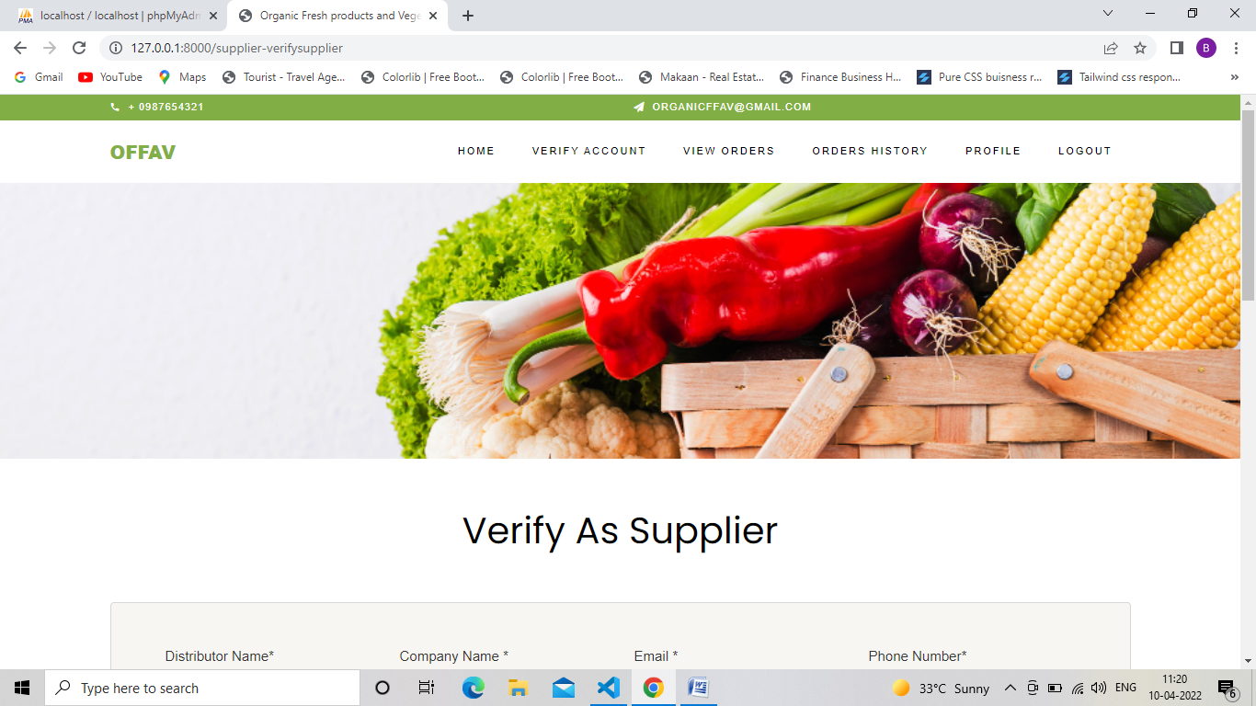

SUPPLIER/SUPPLIER-VIEWORDERS

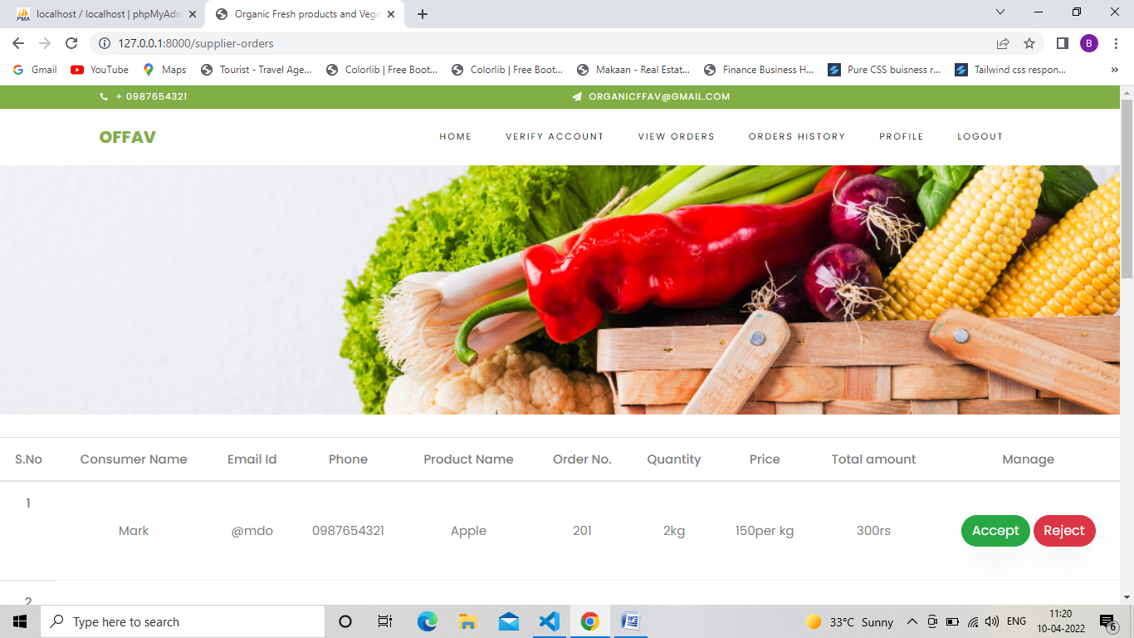

SUPPLIER/SUPPLIER-ORDERS HISTORY



SUPPLIER/SUPPLIER-VIEW PROFILE



CONSUMER/CONSUMER-HOME

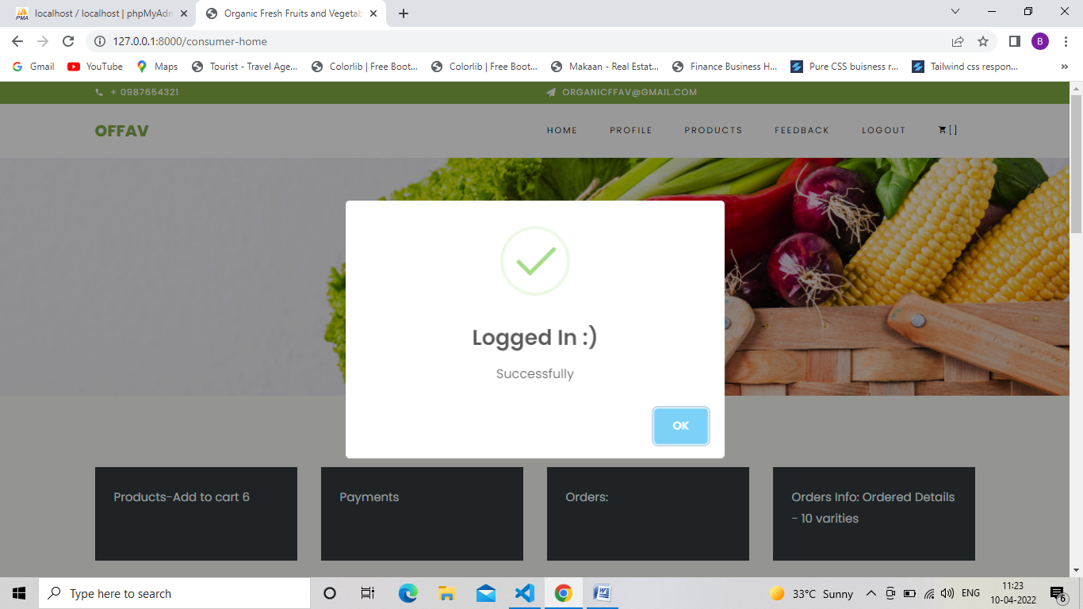

CONSUMER-REGISTRATION

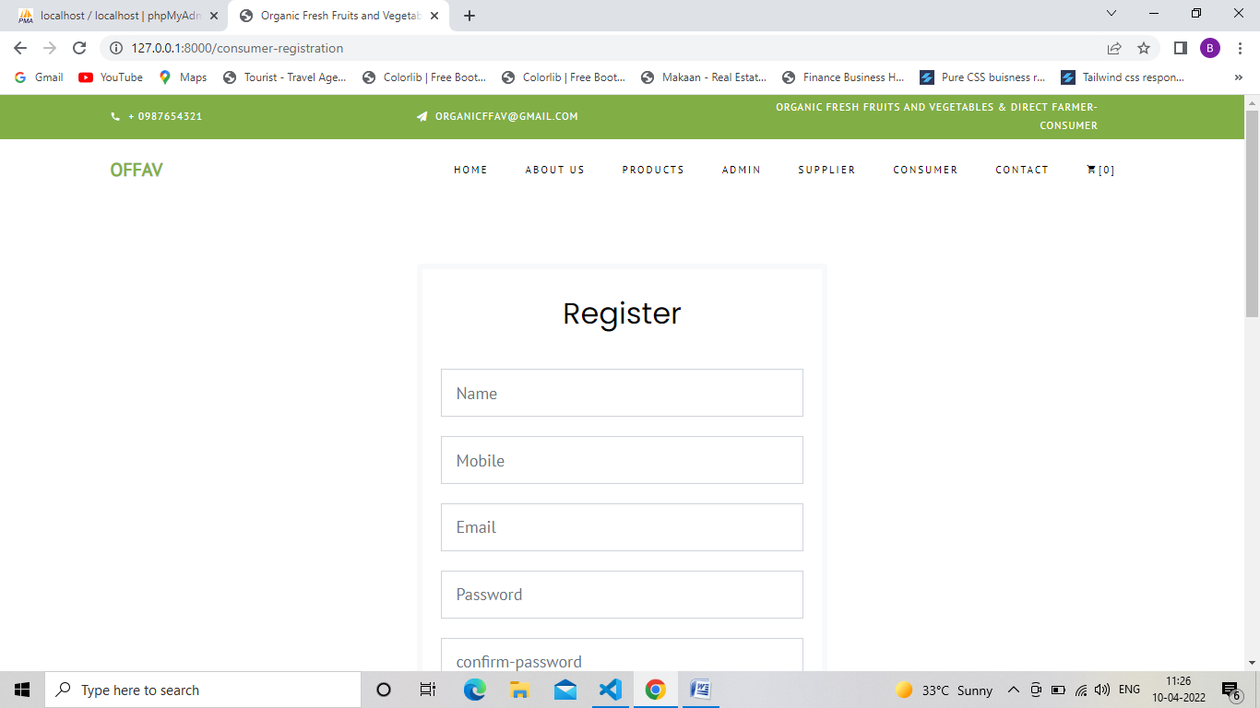

CONSUMER/CONSUMER-DASHBOARD

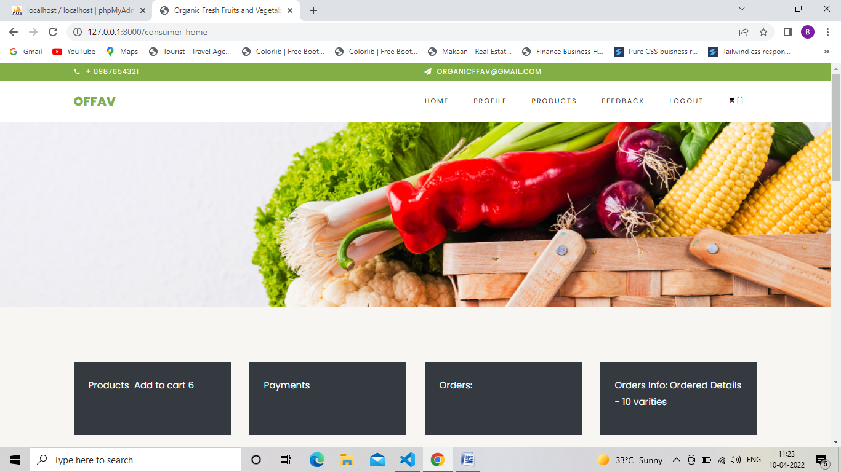

CONSUMER/CONSUMER-PROFILE

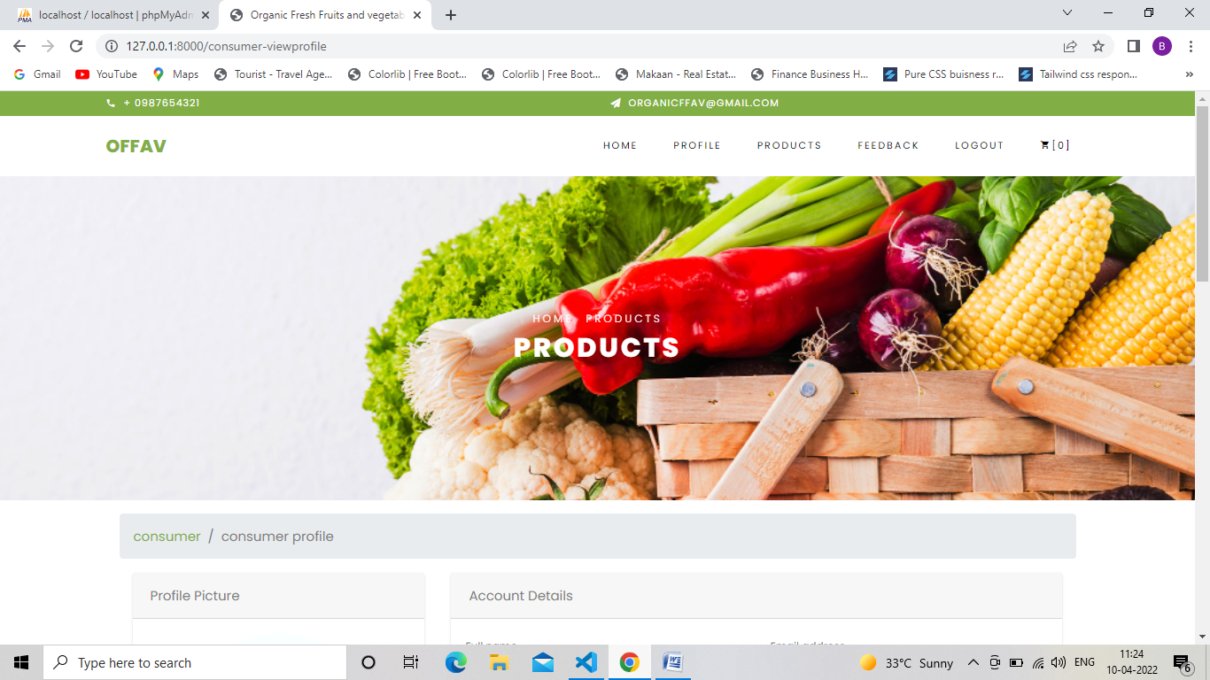

CONSUMER/CONSUMER-PRODUCTS

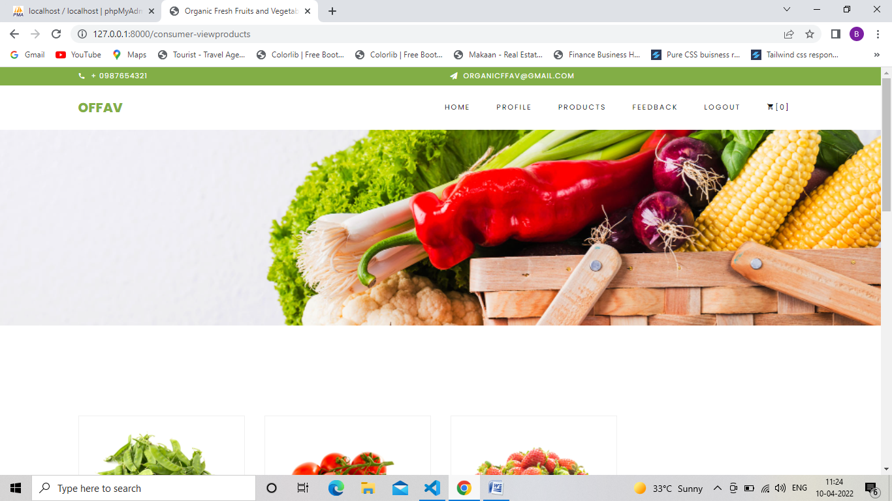

CONSUMER/CONSUMER-FEEDBACK

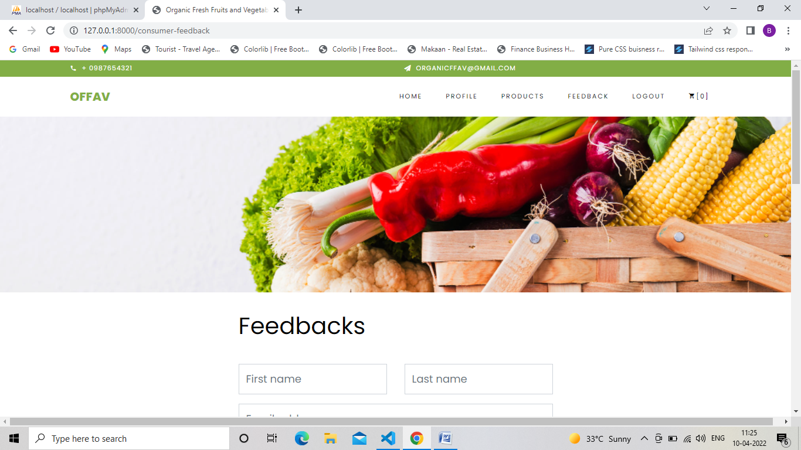

CONSUMER-DETAIL OF PRODUCTS

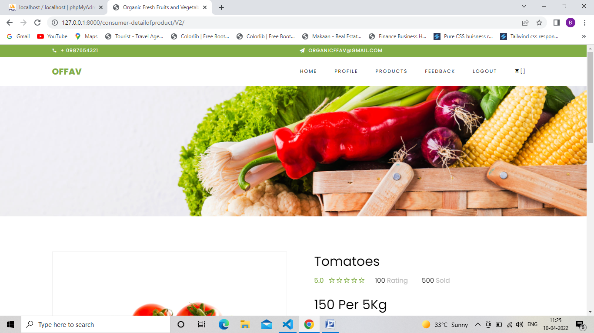

CONSUMER-ADD TO CART

